Tree Spieces Descriptions
B=Beautiful fall color C=Conservation tree F=Flowering H=Good for wildlife I=Introduced species N= Native species U=Produces fruit or nut W=Good in wet areas
EVERGREENS
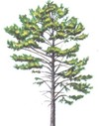 | Austrian Pine (Pinus nigra) C, I, Fast growing, cone bearing pine with long dark green needles, height 60', well suited for almost any area. Very good windbreak tree.
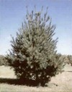 | Eastern White Pine (Pinus strobus) N,H,C, Largest northeastern conifer, long soft needles, height 100', prefers well drained sandy soils. Good windbreak tree
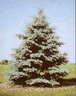 | Blue Spruce (Picea pungens) C,H, Has silvery blue to blue green needles, grows well in most soils except very wet areas. height 80', used as Christmas trees and windbreaks
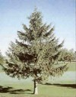 | Norway Spruce (Picea abies) C,I,H, Large, cone bearing tree with straight trunk and cone shaped crown of branches, height 80', Used as Christmas trees and windbreaks.
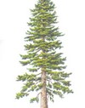 | Douglas Fir (Pseudotsuga menziesii) C,I, Soft medium length needles, fast growing, height 30'-50', Prefers better soil and good drainage.
DECIDUOUS:
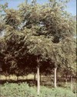 | Black Walnut (Juglans nigra) H,N,W,U, Large tree with open, rounded crown of dark green aromatic foliage, height 70'-90', prefers moist well drained soils along streams, scattered in mixed forests.
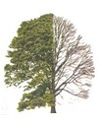 | Pin Oak (Quercus palustris) H,N,U,W Straight trunk with spreading horizontal branches with slender pin like branches, height 50'-90', prefers poorly drained wet sites, easily transplanted because shallow root system lacks a tap root.
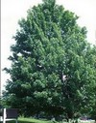 | Red Maple (Acer rubrum) B,N,W, New USDA cultivar selected for its fiery red autumn leaf color, large tree with narrow or rounded compact crown, height 50'-80', wet or moist soils of stream banks, valleys and uplands.
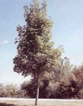 | Sugar Maple (Acer saccharinum) B, C, Unrivaled hard-wooded tree. Stately, long-lived. Rich autumn foliage coloring.
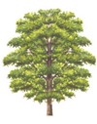 | Tulip Tree (Liriodendron tulipifera) B,C,F A stately tree up to 100 feet tall, Flowers a two inches, cup-shaped, with six yellow-green petal with an orange base surrounding a cone-shaped cluster of pistils.
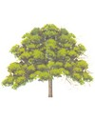 | Eastern Northen) Red Bud (Cercis Canadensis) A large shrub or small tree up to 30 feet. Flowers a very showy, pea-like pink to light purple in color
SHRUBS:
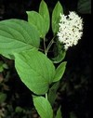 | White Flowering Dogwood (Cornus florida)B,C,F,H,N,U,W, Dense green foliage turns bright scarlet in fall, attractive white flowers followed by red berry clusters, , height up to 40', Grows best in moist and wet soils.
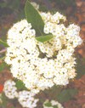 | American Cranberry Bush (Viburnum trilobum) B,C,F,H,N,W,U , deciduous shrub , white flowers in clusters in May, Scarlet berries midsummer through winter, height 8'-12', good plant for wildlife and wet areas.
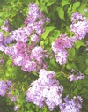 | Old Fashion Lilac (Syringa vulgaris) B,C,F Strong-growing, very hardy, tall-growing shrub bearing large trusses orfragant-scented liliac blooms. Thick, dark, attractive foliage.

