Fish Species Descriptions

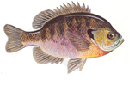 | Bluegill: are an excellent sport and pond fish that grows a little slower  than sunfish. Bluegill will hide in old logs or around plants in the water.  They will bite on many different kinds of bait. When the pond is not over  populated Bluegill will grow to be 7 to 10 inches long.
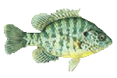 | Redear: Are recommended for deeper ponds and can be stocked along with  Bluegill or Hybrid Sunfish. They are deeper water fish, feeding on snails, and are  usually harder to catch except during spawning season when they are  in the shallows.
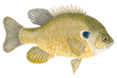 | Hybrid Sunfish: Are a good choice for smaller ponds. This hybrid cross  between a male Bluegill and a female Green Sunfish results in a 90% male,  10% female population, which limits population growth. Hybrid Sunfish can  reproduce if Bluegills are also present.
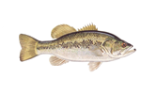 | Largemouth Bass: Are one of the most popular fish in America. They  are predators and work well to help control Bluegill and Crappies populations.
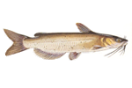 | Channel Catfish: Are compatible with all species in lakes and ponds,  and work especially well with Hybrid Sunfish and Largemouth Bass.
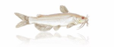 | Albino Channel Catfish: Albino Channel Catfish are an excellent pond  and stream fish. They prefer moving water with a rocky and sandy bottom.  They also like to hide in old logs or holes.
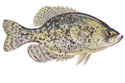 | Black Crappie: Black Crappie is a Schooling fish that like water with  lots of structures and hiding places. They do an excellent job controlling insects.  Crappie average 8 to 16 inches long.
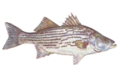 | Hybrid Crappie: Is a mix of White & Black Crappie. The Hybrid act a  great deal like the Black Crappie. They like to hide in logs and around trees that  hang over the water’s edge. Hybrid Crappie will depend on several factors, but  usually are 8 to 10 inches in length.
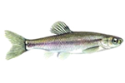 | Fathead Minnows: are especially important when stocking new ponds  as a forage crop for other game fish. You should stock at a rate of 1000 per  surface acre. Fathead Minnows will grow between 2 and 3 inches long and  reproduce in the spring.
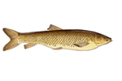 | Triploid Carp: Is an alternative to using  chemicals for weed control. This fish will not  reproduce and when the proper numbers are stocked the  need for chemicals or mechanical weed cutters for  weed control will be minimized. Grass Carp will only  eat pond weeds. These Carp eat most aggressively in  the summer months. Good results are usually seen  after a second season. For continued control of severe  weed problem, fish should be restocked every 3 to 5  years.

